Data Structure Quiz sheet

Ans 1)

Inorder: AKBJC L I DEHFG

Preorder: LKAJBC J EDFG

Postorder: ABCJK I DEFGH L

Breadth first: LKIHAJEFGBCD

Ans 2)

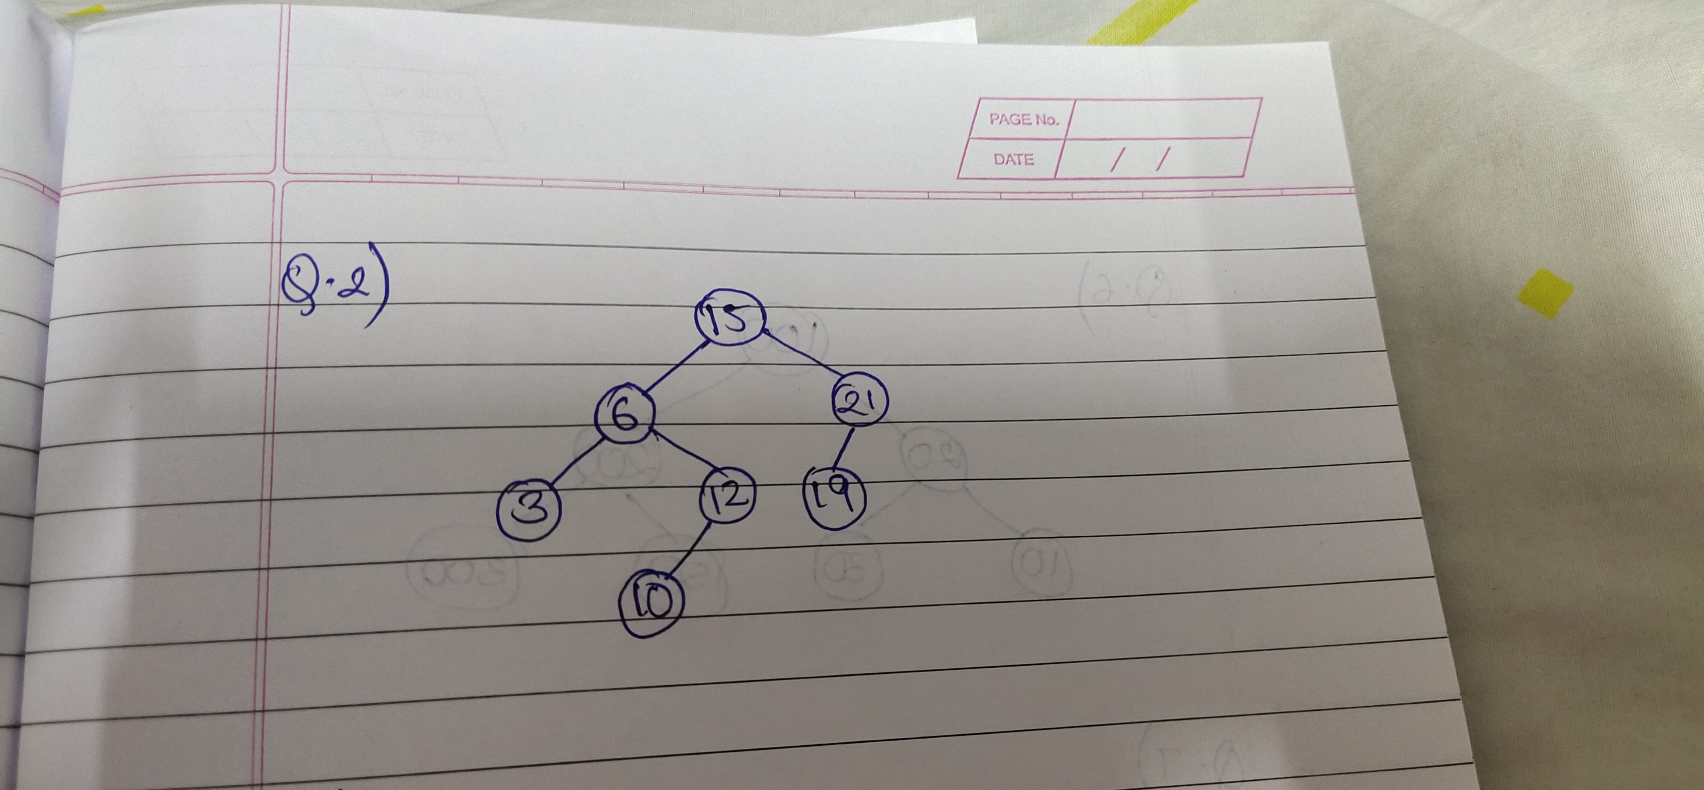

The obtained tree is an AVL tree.

Ans 3)

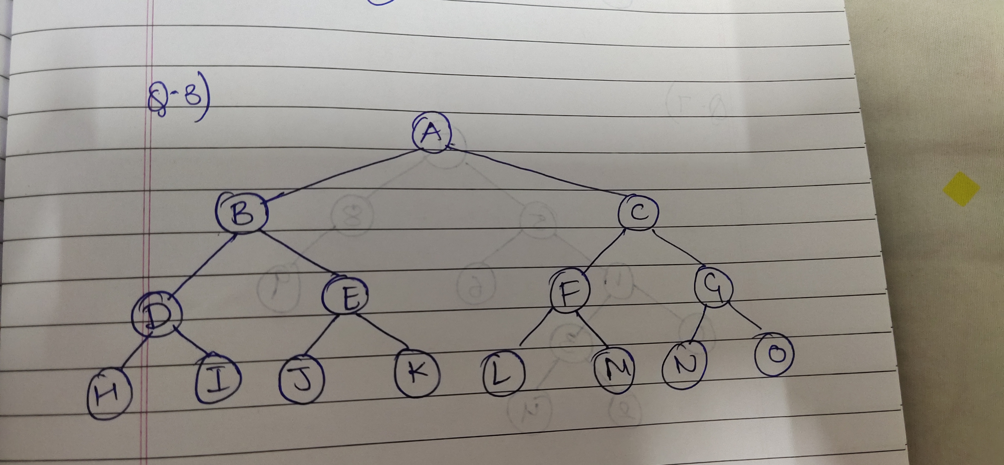

Largest number of nodes:2(3+1)-1 = 15

Smallest number of nodes: 23 = 8

Ans 4)

No, in preorder traversal of a binary search tree the first printed element is the root node which is not the smallest one as in a binary search tree, the value of the left child of the root node is always less than the root node. Hence, it is not possible.

Ans 5)

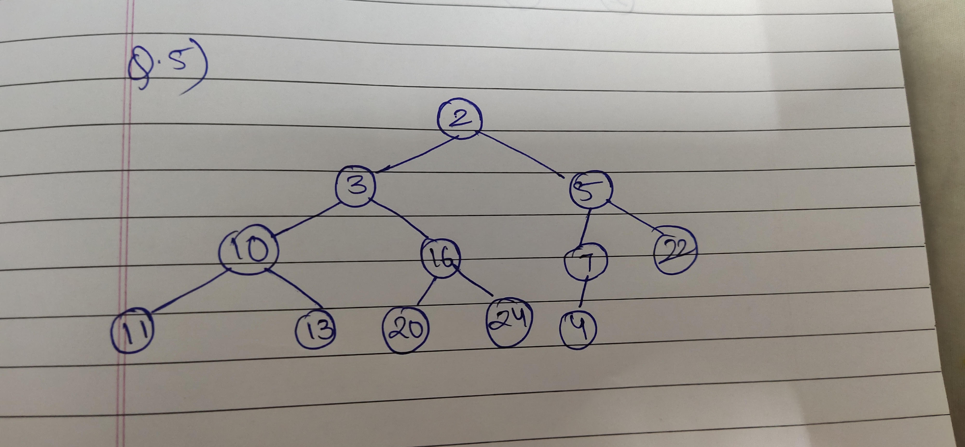

Before performing the operations, array:

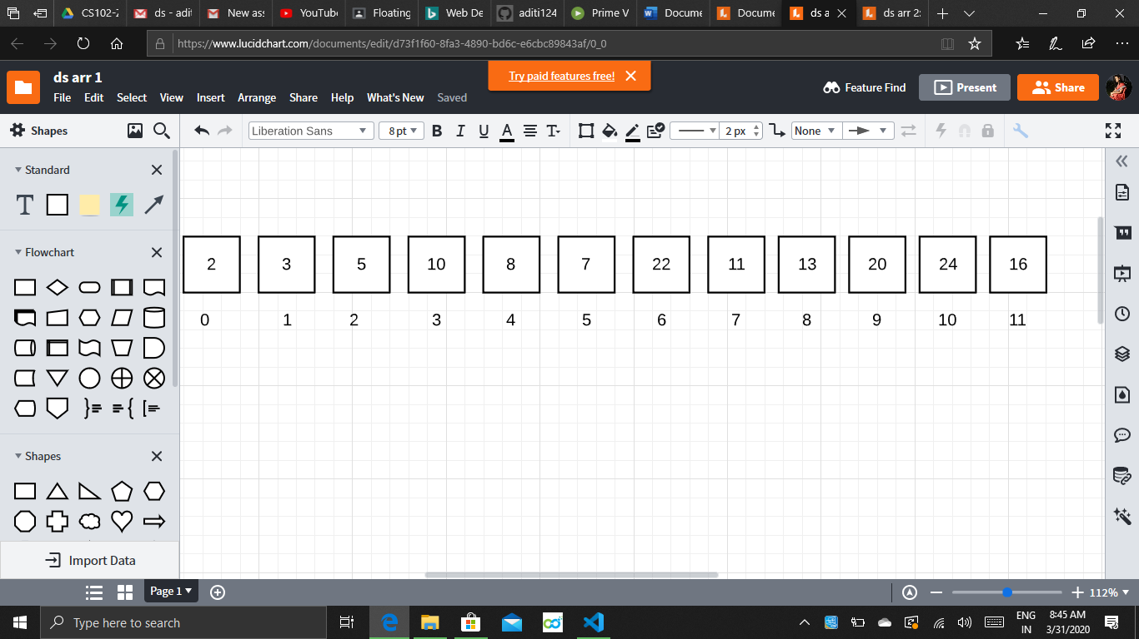

After performing the operations, array:

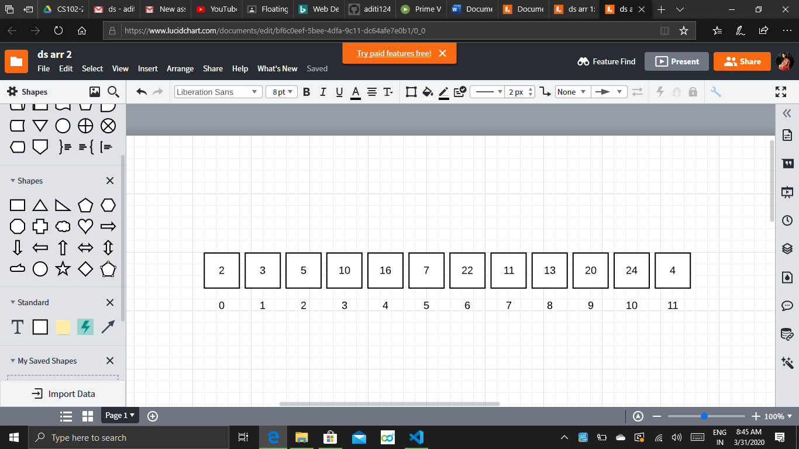

Ans 6)

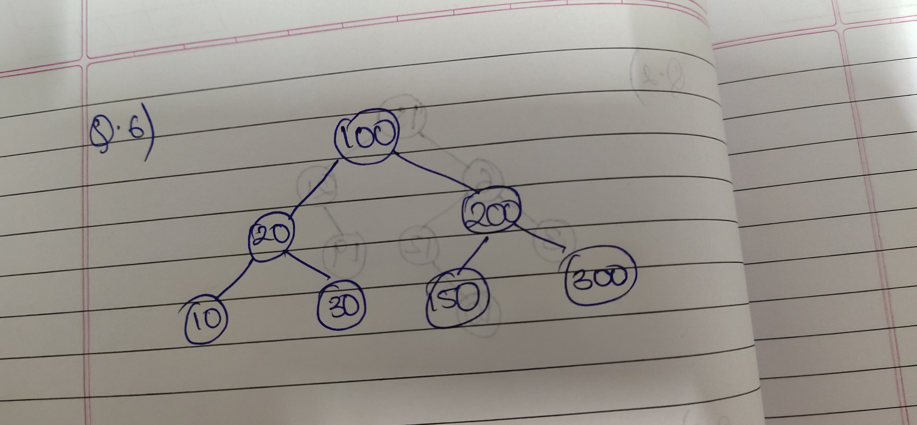

Ans 7)

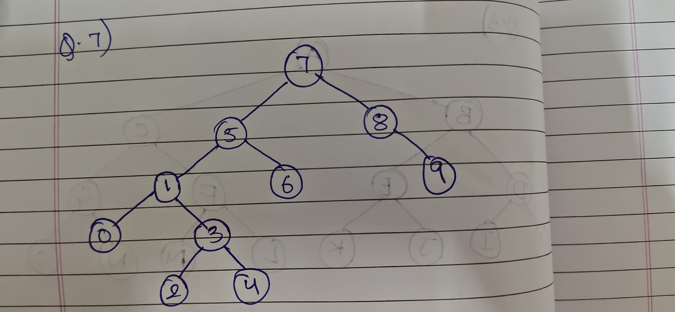

Inorder traversal sequence: 0, 1, 2, 3, 4, 5, 6, 7, 8, 9